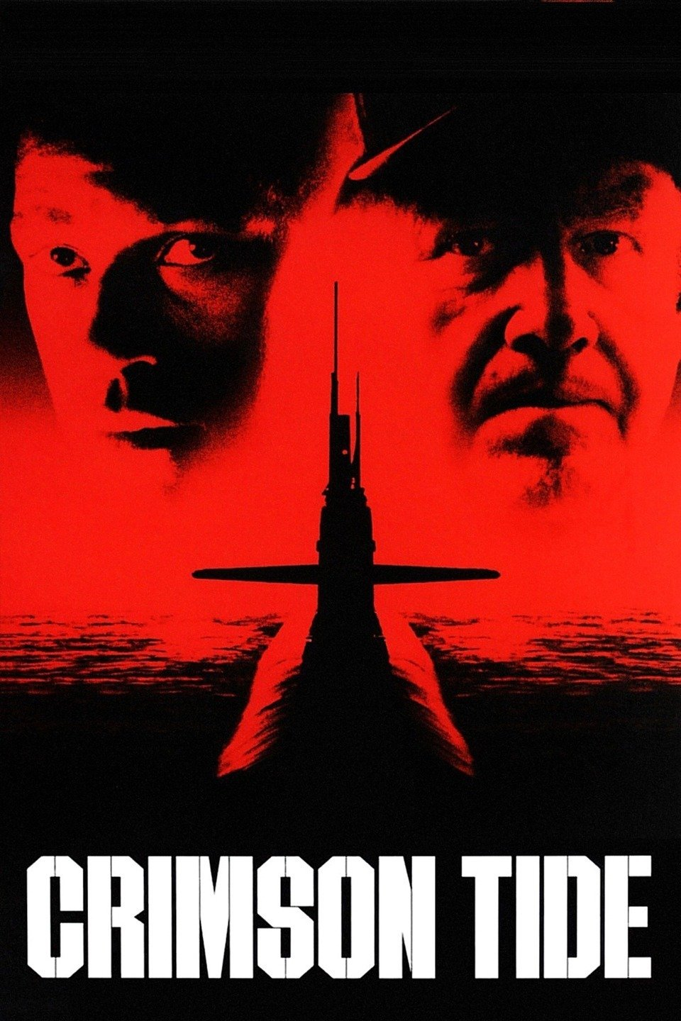

Event by: Olympia Coalition To Abolish Nuclear Weapons nuclearweapons@olympiafor.org

FREE All Welcome

1995, Dir: Tony Scott, 2 Hours Rated R (for Raw and Foul Language)

Wednesday, June 6th 2018, 4:15 – 6:15 Lacey Library, Community Room

Tense Thriller; Nuclear Submarine Is Accidental Nuclear War Likely?

&

Gene Hackman

Denzel Washington